# Unity Store Example

## Invoice

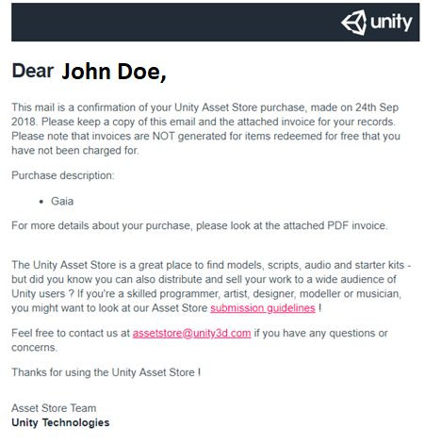

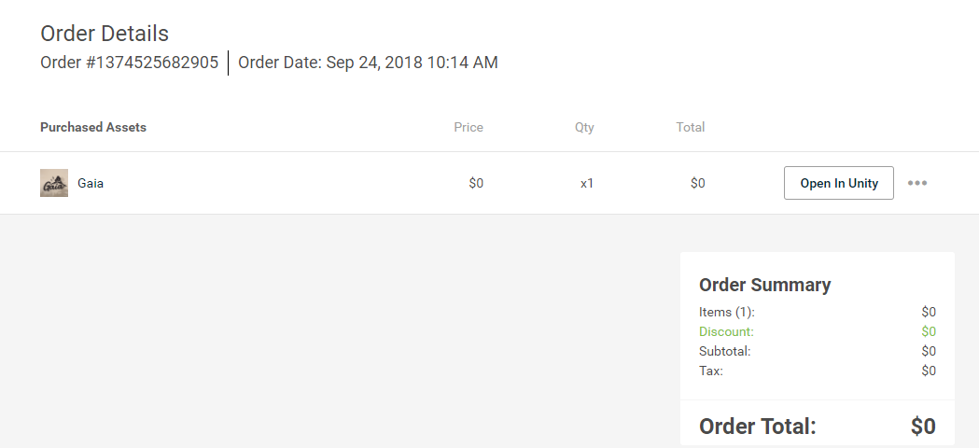

### Attributes (0NF)

CustomerID, CustomerName, CustomerEmail, OrderNumber, Order Date, {AssetID, AssetName, Price, ItemQuantity, ItemTotal}, OrderItemAmount, Discount, Subtotal, Tax, OrderTotal

### 1NF

OrderNumber, CustomerID, CustomerFirstName, CustomerLastName, CustomerEmail, Order Date, OrderItemAmount, Discount, Subtotal, Tax, OrderTotal

OrderNumber(fk), AssetID, AssetName, Price, ItemQuantity, ItemTotal

### 2NF

OrderNumber, CustomerID, CustomerFirstName, CustomerLastName, CustomerEmail, Order Date, OrderItemAmount, Discount, Subtotal, Tax, OrderTotal

OrderNumber(fk), AssetID(fk), AssetHistoricalPrice, ItemQuantity, ItemTotal

AssetID, AssetName, AssetCurrentPrice

*decided to store historical price and current price

### 3NF

OrderNumber, CustomerID(fk), Order Date, OrderItemAmount, Discount, Subtotal, Tax, OrderTotal

CustomerID, CustomerFirstName, CustomerLastName, CustomerEmail

OrderNumber(fk), AssetID(fk), AssetHistoricalPrice, ItemQuantity, ItemTotal

AssetID, AssetName, AssetCurrentPrice

### ERD

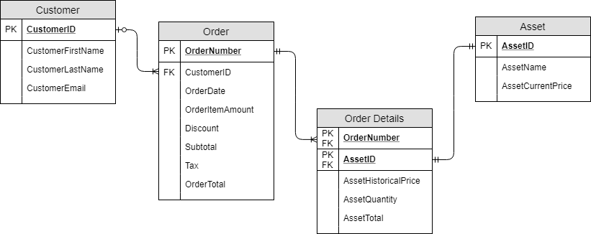

## Product View

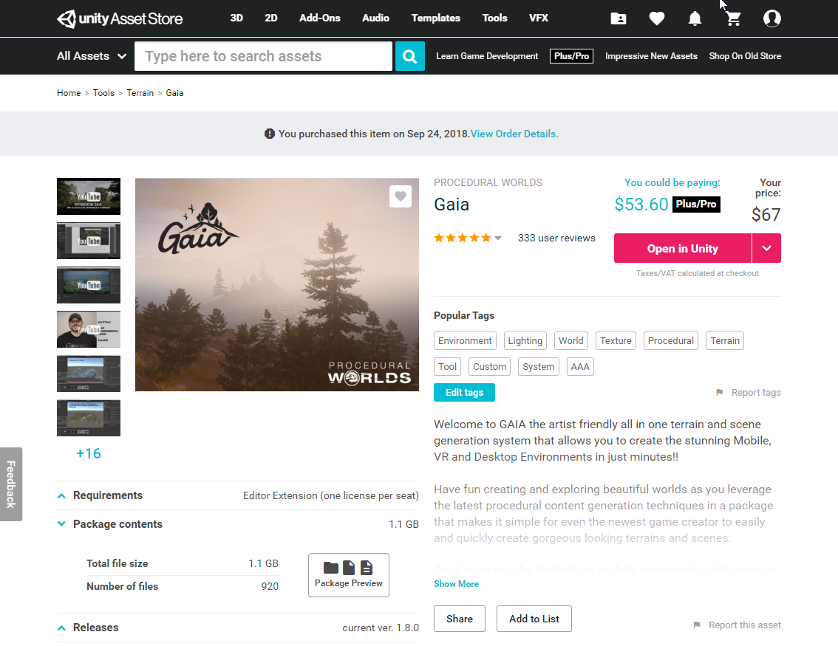

**(This answer has an error in 2NF but was continued for a learning exercise for SL Students – The fixed solution comes after the faulty solution)**

### Attributes (0NF)

PublisherID, PublisherName, ProductID, ProductName, ProductProPrice, ProductPrice, Rating, {TagID, TagName}, FileSize, NumberOfFiles, LicenseType, CurrentVersion

*license type will be asset or editor extension

**Assume users don’t create tags, just pick from a list if they “Edit tags”

### 1NF

ProductID, ProductName, ProductProPrice, ProductPrice, Rating, FileSize, NumberOfFiles, LicenseType, CurrentVersion, PublisherID, PublisherName

ProductID(fk), TagID, TagName

### 2NF

ProductID, ProductName, ProductProPrice, ProductPrice, Rating, FileSize, NumberOfFiles, LicenseType, CurrentVersion, PublisherID, PublisherName

ProductID(fk), TagID(fk)

TagID, TagName

### 3NF

ProductID, ProductName, ProductProPrice, ProductPrice, Rating, FileSize, NumberOfFiles, LicenseType, CurrentVersion, PublisherID(fk)

PublisherID, PublisherName

ProductID(fk), TagID(fk)

TagID, TagName

### ERD

